EF Core 8.0 Guided Hands-On Exercises

Lab 1: Understanding ORM with a Retail Inventory System

1. What is ORM?
• Explain how ORM maps C# classes to database tables.
• Benefits: Productivity, maintainability, and abstraction from SQL.
Solution:- Object-Relational Mapping (ORM): Maps C# classes (e.g., Product, Category) to database tables automatically. You work with objects, EF Core handles SQL generation for CRUD operations.
Benefits:
- Productivity: Less manual SQL writing.
- Maintainability: Code-centric, consistent structure.
- Abstraction: Avoid direct SQL, safer updates, and migrations.
2. EF Core vs EF Framework:
• EF Core is cross-platform, lightweight, and supports modern features like
LINQ, async queries, and compiled queries.
• EF Framework (EF6) is Windows-only and more mature but less flexible.
Solution:-
Aspect | EF Core | EF Framework (EF6)
Platform | Cross-platform (Windows, Linux, macOS) | Windows-only
Weight | Lightweight | Heavier
Features | Modern (async LINQ, compiled queries, JSON mapping) | Mature, stable
Performance | Better with compiled models | Slower
Migrations | Code-based | Code-based
3. EF Core 8.0 Features:
• JSON column mapping. • Improved performance with compiled models.
• Interceptors and better bulk operations.
Solution:-
✅ JSON column mapping
Directly map JSON columns to C# types.
✅ Compiled models
Improved startup and query performance.
✅ Interceptors
Hook into query execution pipeline for logging, validation.
✅ Bulk operations support
Better handling of batch inserts/updates.
- Create a .NET Console App:
Solution:-
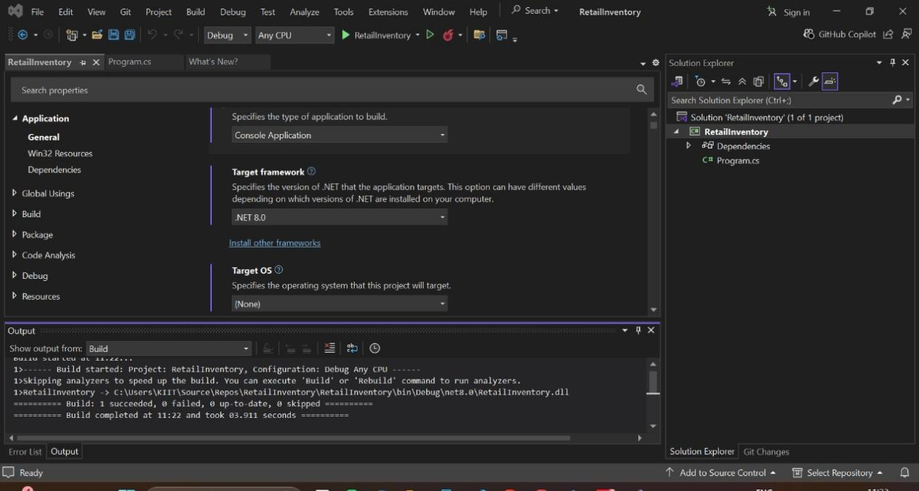
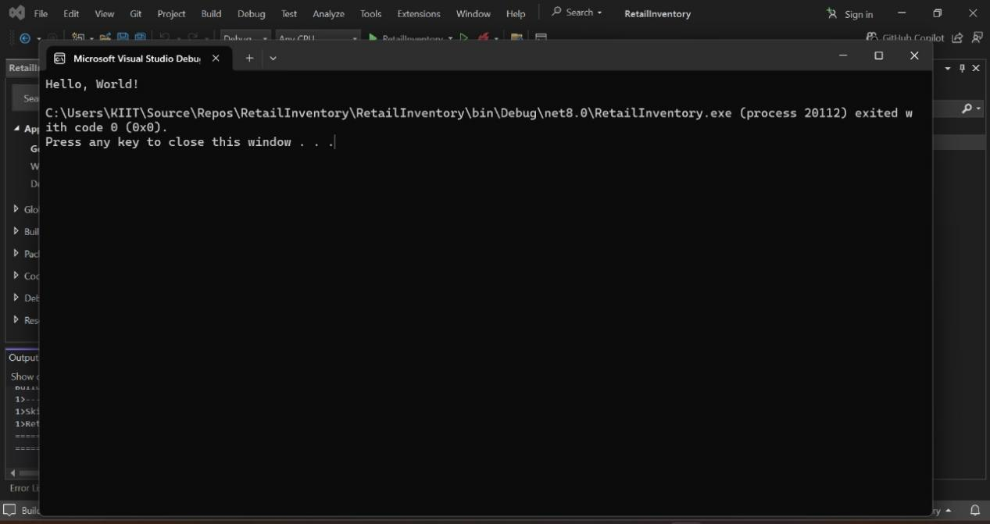
- Install EF Core Packages:
Solution:-
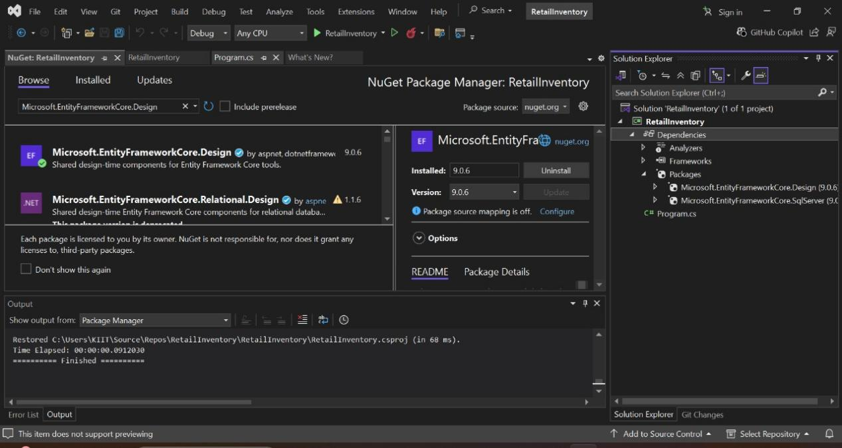
Lab 2: Setting Up the Database Context for a Retail Store

- Create Models:

Solution:-

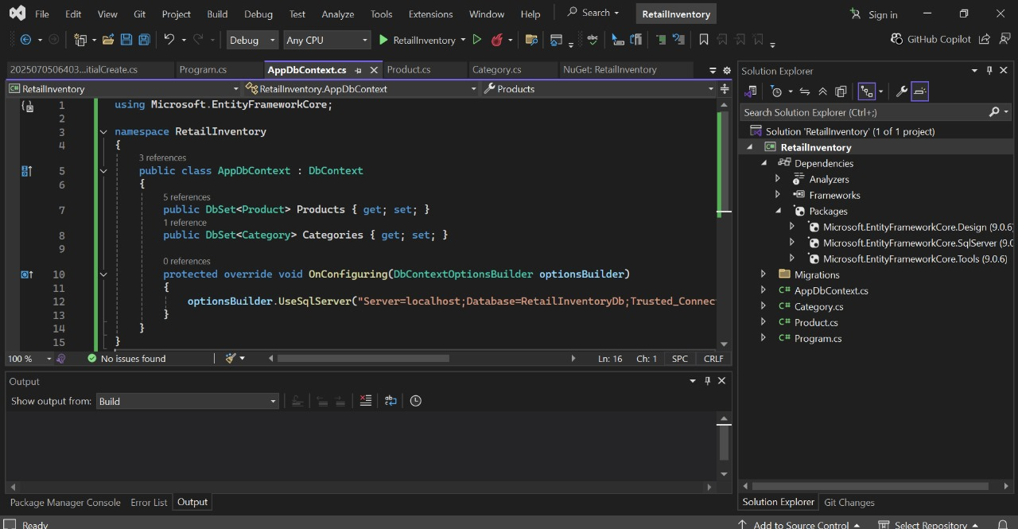
- Create AppDbContext:
Solution:-

- Add Connection String in appsettings.json (optional for ASP.NET Core).

Solution:-

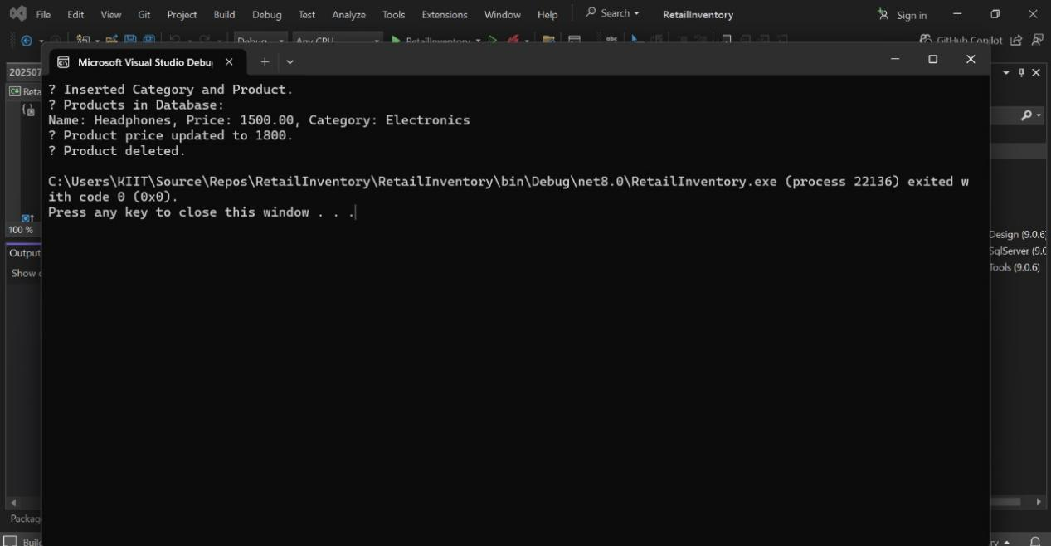

Lab 3: Using EF Core CLI to Create and Apply Migrations

1. Install EF Core CLI (if not already)

Solution:-
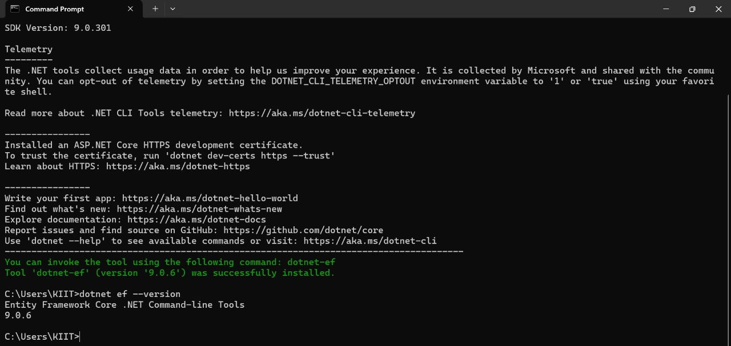
- Create Initial Migration:

Solution:-

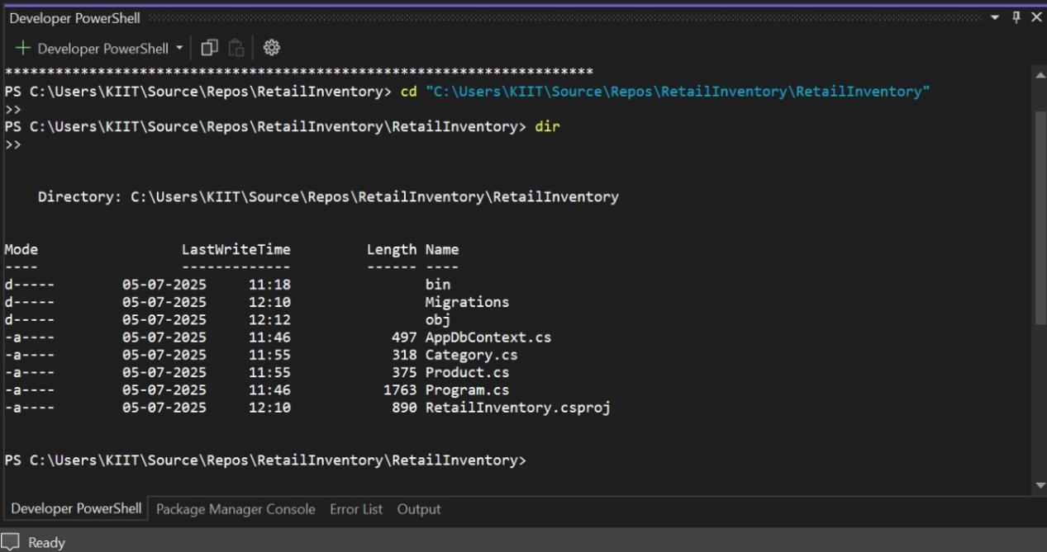

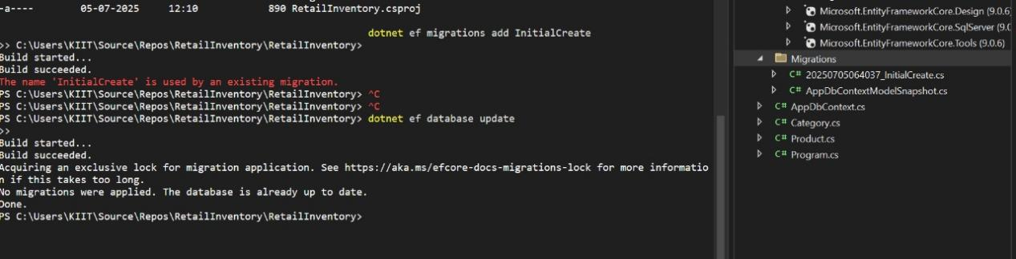
3. Apply Migration to Create Database:
Solution:-
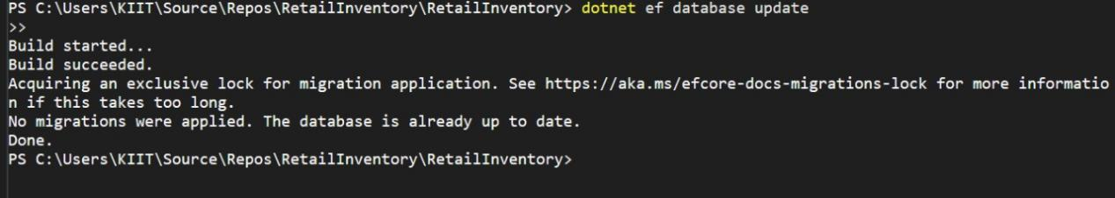

4.Verify in SQL Server:
Solution:-
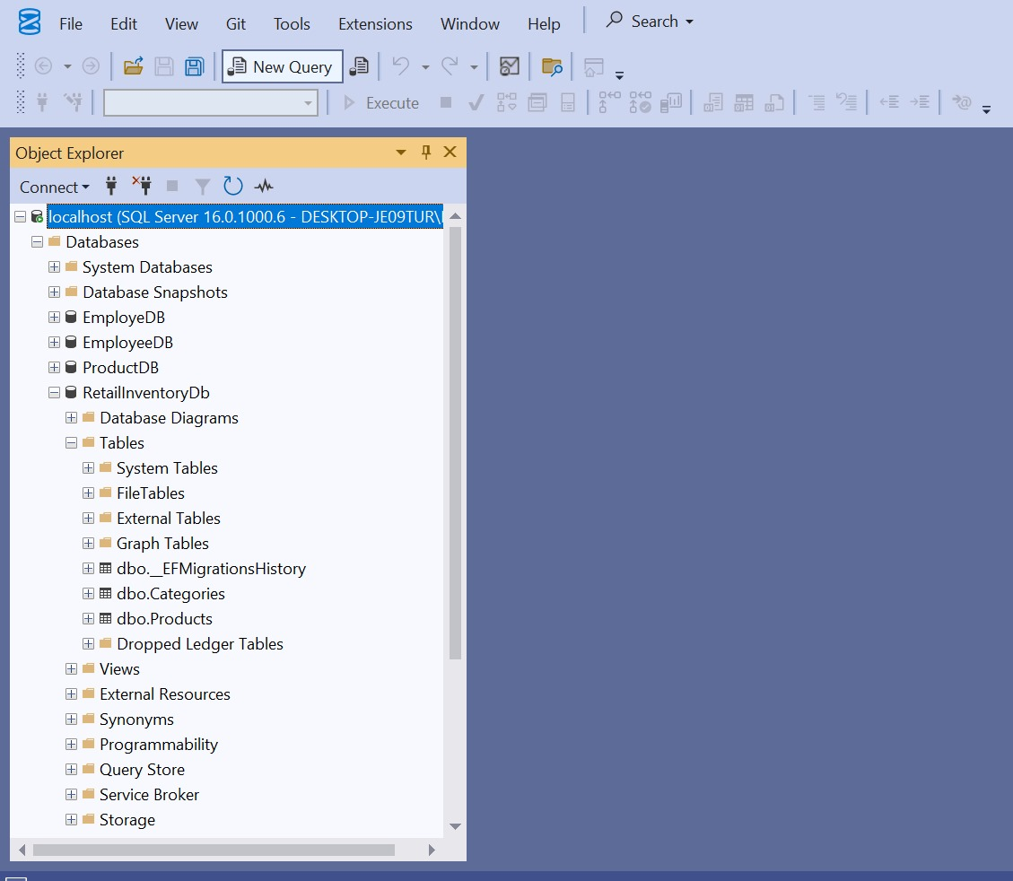

Lab 4: Inserting Initial Data into the Database
- Insert Data in Program.cs:
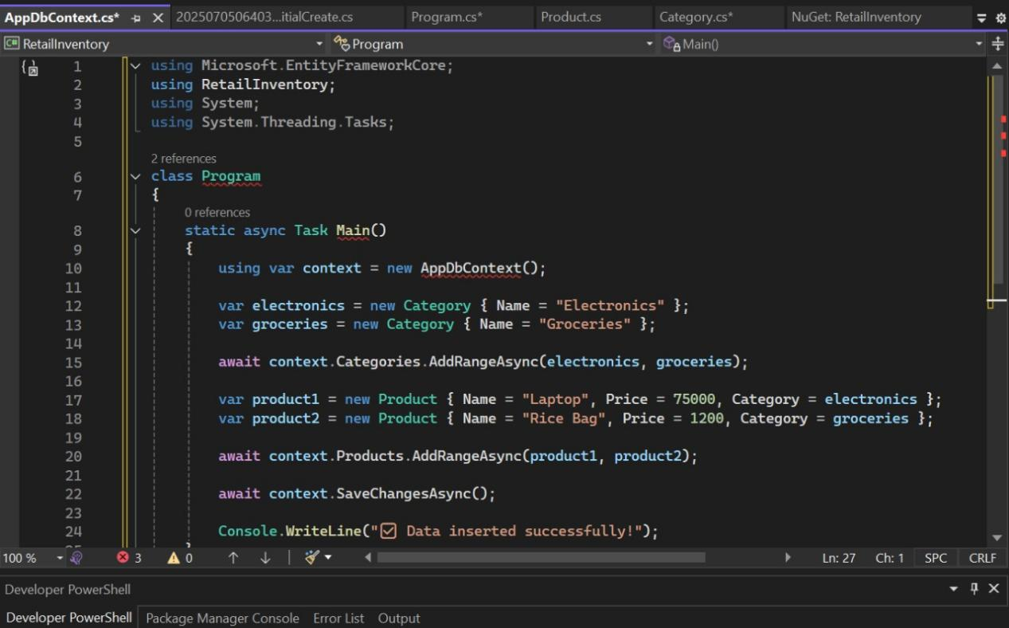
- Run the App:
Solution:-
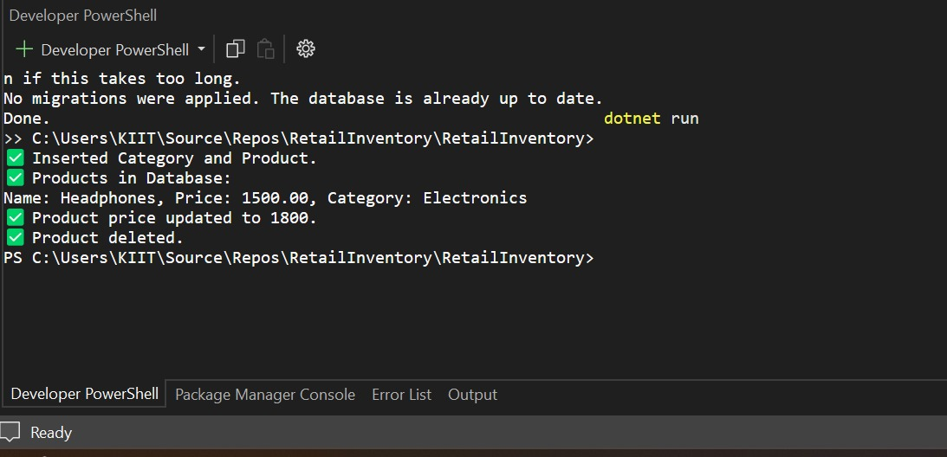

- Verify in SQL Server:
Solution:-
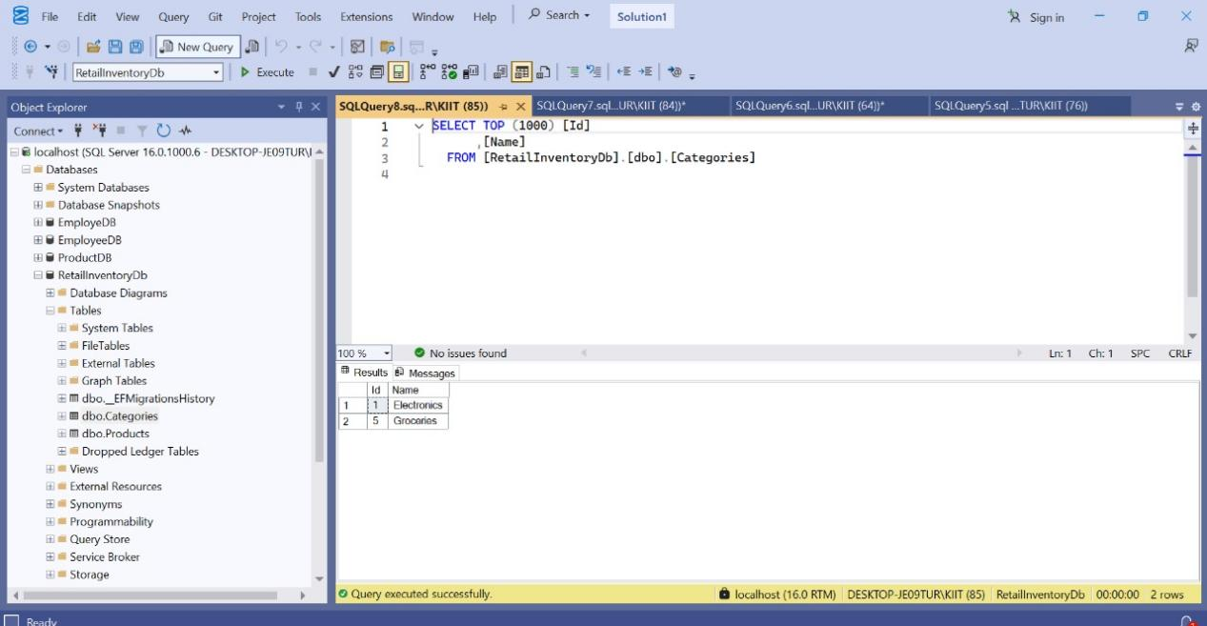
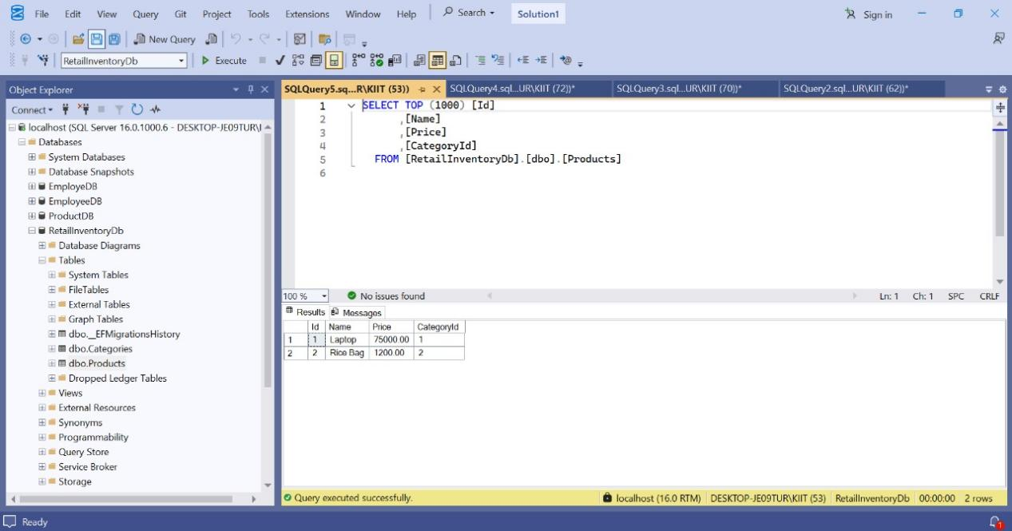
Lab 5: Retrieving Data from the Database

- Retrieve All Products:
Solution:-
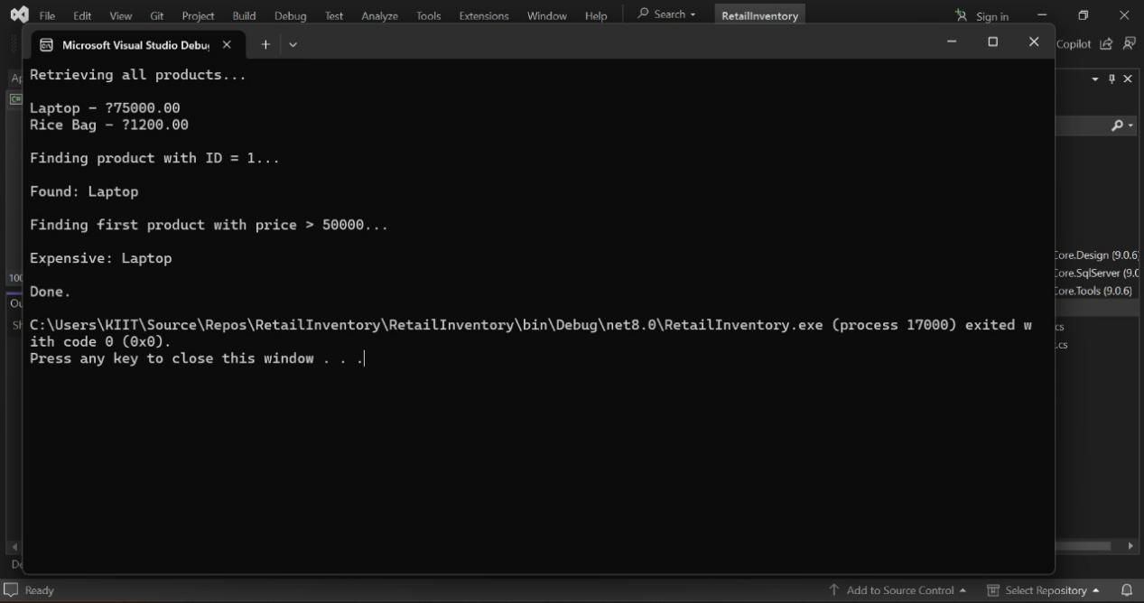

- Find by ID:
Solution:-
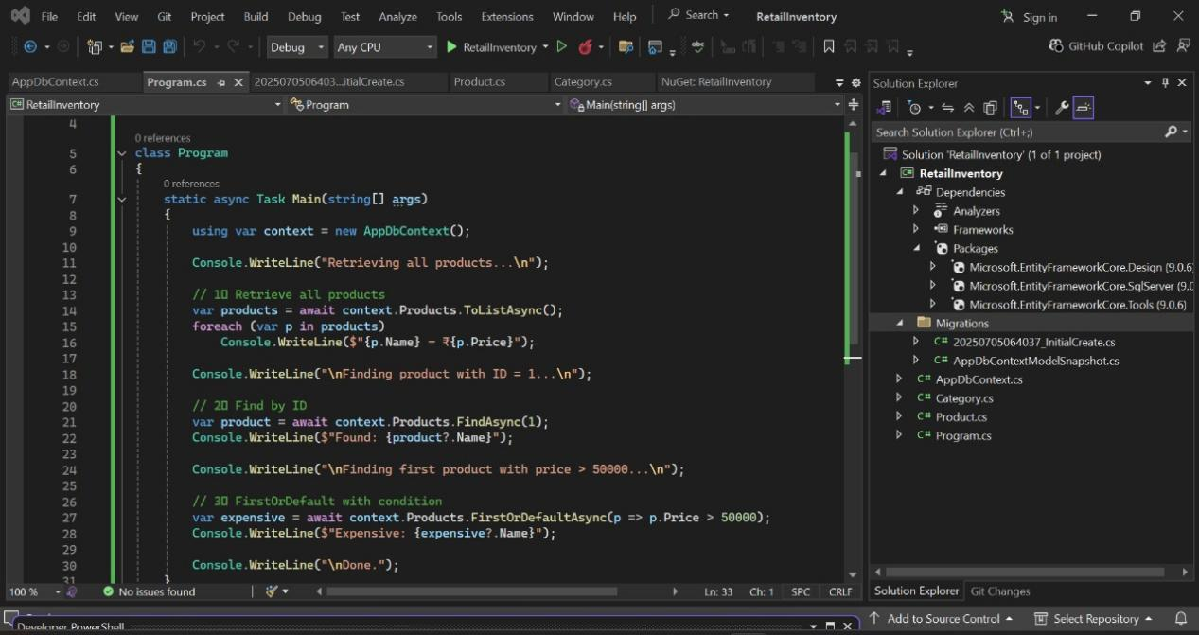
- FirstOrDefault with Condition:
Solution:-
